**Abstract**

InstaHelp is a website that acts as a platform for helping people who require counseling. Any certified mental health counselor can register themselves with this platform and put themselves in the website as a provider of mental health counseling as a service. The Main objective of this website is to provide end to end communication between a patient and their medical counselor. User can choose stay anonymous if they desire to and schedule a meeting from anywhere. As it is a website-based platform, user can avail the services from any device which has web-support and from any location. User can register themselves and search the market place for a medical counselor, they can search for the appropriate counselor based on their problems and avail the services from counselors that are specialized in the particular field of expertise in which they are facing their problem. Field such as types of addictions, bi-polar disorders, marital counseling and such. They can read the reviews/ratings, charges and decide from which counselor they should seek help. If they find a counselor they like, they can book an appointment with the medical doctor. The user can leave a review after the counseling for other users. If the user is not comfortable in showing their face, they can also opt-in for text or voice call method of communication. Afterall the ultimate objective of this website is to provide certified mental health counseling to people who seek help while wanting to be in their safe comfort zone. The website’s front-end will be developed with React framework using JS ES6, Babel and many other frameworks such as bootstrap. The back-end of the server will be developed using Node.js with Express as the library for providing RESTful API. The website will use MongoDB which is a NOSQL type of database.

**Introduction**

Mental health is one of the most prominent yet neglected issues that is faced by people around the world. According to mental health statistic for England, a research study by House of Commons Library states an estimation that 1 in 6 adults have experienced a ‘common mental disorder’ like depression or anxiety in the past week. It also states that 1 in 8 children from age 5 to 19 are estimated to have at least one mental health problem. This is just one study that provides a miniscule information on a very vast problem that society is facing right now. On top of this, we are facing a pandemic which is causing an economic crisis in every country. Most of the individuals that face mental disorder, strays away from the society. Most often never getting a chance to get back and normalize. It ultimately leads to bad health, homelessness, violence/crime, poverty, addiction, substance abuse and many more such problems.

The biggest issue regarding mental health right now is not that it happens to many people, rather it is due not being identified as a mental disorder so that it can be viewed as a problem. If it is not seen as a problem, no-one tries to correct the issue until it is too late to be corrected. All of this happens because of the stigma that is attached to mental disorder. According to a study by department of psychiatry of Leipzig University, there is proof of a particular stigma attached to seeking help for mental problems. Which further leads the victims of mental disorder to never seek help. The paper also suggests that de-stigmatization of this particular problem will result in more people attempting to seek help for themselves. This is what we hope to achieve by building this platform. We want to address the issue that is neglected because it is considered as weakness to show that a person requires help. We want to directly reach these people, who are unable to reach out for help. We believe that it is possible to solve this problem in a unique way instead of tradition method of counseling. If we get rid of the discomfort or the association of weakness with mental disorder by completely removing the step of getting out of comfort zone and going to a medical institution, more and more people will realize that they are facing a problem which requires a help of a professional and there is nothing wrong with seeking help. This is what we hope to achieve, where a patient can stay completely anonymous if they desire to do so, and get help from professional doctors from their homes. Our platform will act as tool for facilitating the communication between such people in need and the ones who can provide help.

**Technologies used.**

* Node.js with Express library to provide a RESTful API.
* Using MongoDB as a database for the application. The NoSQL based storage is flexible and the flexibility it allows to change the storage structure of the documents is very well suited for the project in development. MongoDB will not be directly used inside Node.js, instead mongoose library will be used for cleaner and readable code.
* The website will use React.js to develop its front end.
* Many other libraries such socket.io and more will be used for adding functionalities into the website once the basic structure is built.

**Process overview.**

Briefly there are two major processes involved in the website. First is the registration sub-process which will admit the new users into the system and login sub-process which will authenticate the user. The second process is where the main operation of the website will take place. Where, the user can browse the page where they can find an appropriate doctor according to their wishes, needs and requirements in general. The user will be able to set an appointment and pay the doctor online. The website will create and maintain sessions automatically on the set and agreed date time by both the parties. In the end user can leave a review of the doctor for other users regarding the degree of helpfulness the counseling provided. On the other hand, the doctors will leave a remark regarding the patient, the data can be used for further research and development of software.

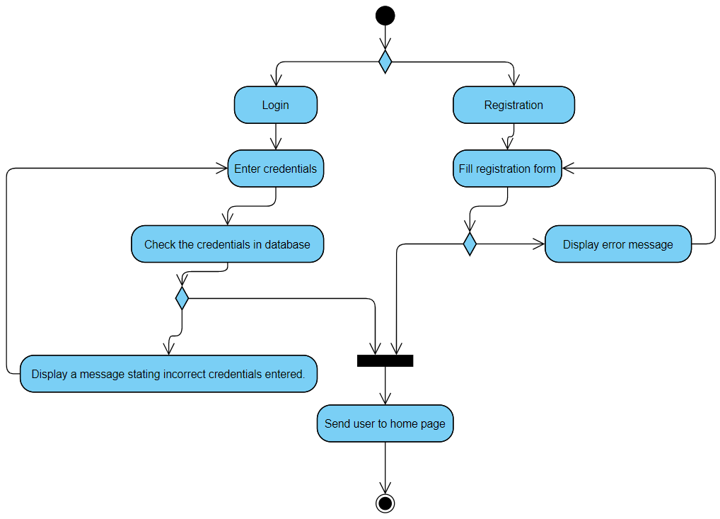

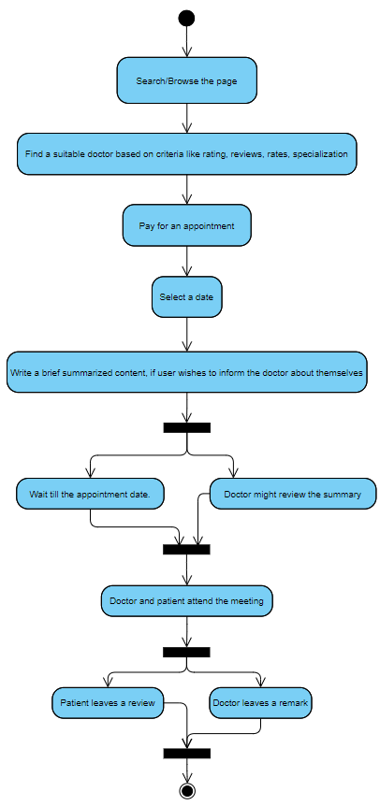

**Literature review**

The major elements before we dive into the development of this website are scientifical reason and requirement of such website to exist in the first place. Another element is estimating and anticipating the effectiveness of such type of online counseling and how likely it is to genuinely provide help to such patients. To understand the effects of mental disorders on society and economy and the barriers, that stops such people to correct and normalize themselves and to ensure that this solution is actually impacting such people in positive way.

There are vast types of mental health issues and in some cases the patient themselves does not know that they have a problem. However, there are also cases where the patient starts to realize that there may be a disorder or abnormality they might have. Not every one of these cases require medical care from a professional but some of them do. The paper by (Schomerus & Angermeyer, 2008) in University of Leipzig came to a conclusion that there were roughly 3 levels of discrimination of help seekers. Adding to it, they also stated that de-stigmatization can heavily increase the readiness of the patients in seeking help from professionals. It emphasized that increasing the awareness and basic knowledge about mental health and its impacts can also be helpful and that it is at the core of seeking intentions. The mental health issue is very complex and there are many variables that are needed to be carefully observed to find correlation among them. This makes this study highly open for further development. Although we cannot discard the conclusions directly, we also have to consider the possibility that these are not entirely the causes. It is also to note that most of the case studies in the research were based on a specific type of mental illness which is depression. There are many good incentives to investigate and inference based on this disorder but we want to focus on cause and effect about all types of disorders as our website has broad and generalized target. Paper heavily assumes that in most cases depression is self-diagnosable. It is safe to assume that these problems of stigmatization affect other disorders too at least to a certain degree if not more in cases such as substance abuse or schizophrenia. Major improvement seems to be possible in this area and more research can be done. What we learn from this especially for our own use case is that by eliminating the whole problem of stigmatization can definitely boost the morale and incentive to seek of help of such patients. By making it available/accessible at home and the element of anonymity both work in the favor of improvements in general.

Another paper (Barney, Griffiths, Jorm, & Christensen, 2006) also pointed out the same issues in 2006. They conducted a study with 1300 adults randomly sampled from Australian community. The sample was given a questionnaire consisting of questions like depression vignette and, demographics, depression experiences, and symptoms. If the person was facing any symptoms currently. One of the most important question was focused on how they perceived themselves in contrast to earlier paper where it was mainly focused people around the subject. The study concluded by stating that in general many people thought that they felt embarrassed from seeking help. They believed that the action of seeking help will change the way people would think about them and refused to take action. Although the responses did vary, they key factors were self-embarrassment and expectations that it will negatively affect views of people around them. In many cases people also believed that this type of thinking impacted the subjects in the sample more negatively adding more problems. There are abundant amounts of sources available that re-enforces this for us. Referencing more papers will add other minor factors but in general the core statement stays the same.

In the recent paper ( Zhou, Harding, Edirippulige, & Smith, 2020) shows the grave impacts of covid-19 on the society. The paper states that as of march 19, 2020 there were 1,98,000 covid infections recorded globally. At the time of this study 5th may 2020, there were 154 million cases in total worldwide. The pandemic has caused many families to lose their loved ones, creating tremendous emotional distress. There are other factors like poverty, debt, jobs/wages, security, bad investments and many more adding emotional stresses more than ever. Isolation at home has led to reduced interaction with family, friends and creating an environment which is worsening anxiety and depressive problems. If these are left untreated, they will leave a long-term impact on society while adding costs for managing the same illness. During the crisis, when the medical infrastructure is already at its limits, it’s being nearly impossible to address these issues in such medical facilities. On top if there is a risk of contraction to the virus which further discourages the patients to seek help. In most the cases of depression, patient also feel other problems like phobia which contribute in not seeking help. The paper heavily emphasizes on making mental implications of covid-19 on the society to also being addressed as one of the biggest issues that are needed to be treated can cannot be overlooked. The solution of any kind of telehealth, video-conference, e-mail, telephone, voice-call on any devices can be one of best and most powerful weapons against fighting these issue mention above. It will help people who have lost their loved ones to cope up with the trauma and overcome these difficulties. People who have lost their jobs, homes, and loved ones are using substances like alcohol or other drugs to cope up with losses. These are not the correct way to address these issues, and are likely to turn these acute conditions into chronic conditions which will leave life changing impacts on these people. It is observed that china is already addressing mental health issues and actively providing various telehealth services during this outbreak of covid-19. These services are prioritized and focused on people with higher risk of exposure of covid-19, including nurses, doctors, clinicians, policemen, guards and recovered patients. Australian government funded better access initiative program to address mental health needs in rural and urban areas. Including covid-19, Australia also had bush fires which caused loss of property and other issues to the people. For this reason, added the mental health care to their Medicare which is a right of every citizen. They are also funding educational campaigns to create awareness and help people in long term rather than just focusing on economical and short-termed physical health issue. All the governments in the world should be following this lead and should not ignore the heavy impacts pandemic is making to the people mentally. Right tools and devices are needed to be planted to fight and recover from this problem.

(Paulik, et al., 2021) provides a great perspective from the side of clinicians who are recently trying the new method of delivering their service. Image rescripting (ImRs) is a technique used to treat patients suffering from PTSD or related intrusions. It is found useful and effective on many cases of OCD, depression, PTSD, BPD, binge eating disorder, body dysmorphic disorder, paranoia, hallucinations and many other such disorders. The technique focuses on recalling a traumatic instance occurrence in patient’s life and providing an alternative or rather a safer narrative to the actual occurrence. This allows the patient to modify and provide themselves a safer ending which leads to changing the emotions attached to the traumatic experience. When the face-to-face delivery of such techniques are nearly impossible due to the emergence of COVID-19, there is a need to place an alternative to this issue. The paper also states that previous systematic reviews have found quality, satisfaction, dropout rates of the face-to-face are almost identical to telehealth. After conducting a review, one of the most important findings were that people (clinicians and patients) both were arguably under lower stress in countries with lower death rates, countries like Australia compared to countries like Netherlands where there was a surge of cases (waves). On top of that there were restrictions placed in such countries which incentivized patients and doctors both for choosing tele-communication over face-to-face treatment. One of the other important findings were that people with big houses, and multiple rooms with thick walls were generally having more positive and effective treatment compared to those who were attending with housemates, wife or other family members around. It tells us strikingly, that patients prefer being alone with the doctor during the treatment. It is recommended by the doctors that delivery of ImRs should be done in a safer environment where patient is not just physically safe but rather when patient might not want other people to hear their private discussions, even by people who are close to them such as parents, wife, children who are not the perpetrators of the traumatic experience. One of the patients in study, reported that she rescripted the treatment in a different way because she felt she was being heard by her parents. The patient was not even sure if her parents were able to hear the communication but still felt self-conscious enough to change the way she wanted to rescript the treatment. She states that she might have done it differently if she was alone in the house. This brings in a lot of important information for the study. It tells how the patient reacts differently and heavily requires privacy for themselves. Some people preferred to do it face-to-face but most in general gave a positive feedback to tele-communication. Some patients reported that they felt much calmer and safer by doing this at home rather than in the clinic and were able to concentrate much more effectively. Some felt that the anxiety before the commute to the clinic was completely removed and felt that it helped a lot in attendance rate and feeling safer in general. The patients could stay in a environment where their toys, cushions, pets and other things like that were around them, they didn’t need to dress formally as the doctors won’t mind what kind of attire patients had. On the other hand, 2 of the doctors had reported that telehealth seemed less convenient for various reasons. The patient-doctor interaction time was reduced by around 5-20 mins on average as it was more frequently and easily accessible. Some of the doctors stated that they were not able to see patients’ whole body, which resulted in a lot of loss of information that could be achieved easily in face-to-face type of communication. Acts such as clenching fist, foot tapping and such provide a very good input in diagnosing the problems in mental health disorders. Many times, patient’s camera was too focused on their face, or sometimes they were not even in the frame. Some of the doctors advised patients to setup 2 cameras, one for the whole body and one for the face for better understanding. Doctors felt that back-to-back online therapies were more exhausting compared to normal face-to-face communication for reasons like compensating the lag, offset eye contact and other technical reasons. Some of the patients did not reveal that there was someone with them in the room, cases like these reveals that there are many things we don’t know about tele-health. It was also observed that many patients were not willing associating their homes with the therapy as they were worried that it would change their views and impact feeling of being safer at home. In many cases, device was also big problem, many patients did not have a good device with a proper camera for the treatment. There were problems like internet connection or power cutoff that ended the session abruptly, doctors had to advice patient to join from their phones in such cases and asked to keep their phone/laptops charged. Bonding between the doctor and patient is also very important part of the process of treating the patients. Patients felt that they would have bonded much more deeply and fast in face-to-face type of communication. Some doctor-patients also agreed that they bonded much better than they would have in a face-to-face session due being in comfort. One of the problems in telehealth is that the doctor cannot look at screen as they have to look at the webcam directly to maintain an eye-to-eye contact with the patient which is very crucial in their practice for treatment. Due to this, doctor was not able to observe as good as face-to-face communication. On the contrary, patients had to wear a mask continuously due COVID-19 restrictions which also acts as a barrier in understanding facial expression which also contribute to practice of treating the patient.

(Rowland, J, Holme, Powell, & McGregor, 2020) According to WHO, mHealth is any medical and public health practice on a mobile device. Over 2.5 billion people in world own mobile phone which can be used to provide treatments to patients remotely. According to a study around 50 million users use various kinds of diagnostic apps for health-related issues. An audit by a popular symptom checker app found that advice was given in 80% of the emergency cases in a clinic in US out of which 34% were considered as accurate with 55% as appropriate. Patients were more likely to take their medications on time because of the features in app that regularly instructed to do so. Setting up these schedules were the biggest issue as most would either do it, entirely or do it incorrectly. A meta-analysis from 2019 stated that 66 randomly selected controlled trials showed that fighting depression, anxiety and stress was easier and effective on telehealth compared to control groups. Although the same study did not show any difference in face to face and telehealth by a large margin. Vast part of Africa is having now been covered with strong mobile phone coverages. In places where actual health infrastructure is very poor, there is a huge potential and capability of phones providing actual verified information access to people and can provide a better quality of life. Another interesting thing to learn by this study is that at a global scale different region have different issues and societal problems. Which can be a barrier in the treatment even for a certified doctor who are not familiar with those issues. This can lead to treatment being way less effective compared to face-to-face treatment as the doctors in latter type are generally from the same area as patient and are well versed with problems and issues faced by people there. It is especially important when it comes mental health as these factors play a very big role compared to telehealth applications for oncology where the doctors are specialist for cancer type treatments.

(Tang & Yang, 2010) MedHelp is a healthcare information site which was born as an online social media medical networking community during the Swine Flu epidemic of 2009.This Flu had rapidly spread and evolved and had spread across the nation and world. Since social media websites had become very common and heavily used, more and more people were looking at these websites like Facebook, Myspace and Twitter for knowing more about the Flu. This helped people to interact with each other directly with each other and connect with more people and organizations. The study of identifying information flow and its consequences through social platforms is very old in itself. But complete belief in information available is dangerous as it can also lead to spread of inaccurate or harmful information. This is why online trusted verified sources are necessary during pandemics and disease outbreaks for people to follow and connect. Researchers made this MedHelp website to involve and make use of this community based health networking system to see which users or people influence opinions and beliefs of people the most. MedHelp became one of the largest forums for medical and pandemic related information in the world during the 2009 Swine Flu crisis. The goal of the researchers and inventors of this website is to develop a hybrid model which take links and content on the website and also quantify user influence in forums automatically using different methods and formulas. UserRank algorithm and other such features were created to find out who people listened and trusted the most during the Swine Flu crisis. The researchers created methods Based on the framework and the techniques proposed in this paper. The researchers can be able to build a real-time system to monitor those important forums to identify influential forum users which is the method used in the MedHelp app so as to stop misinformation from spreading and to highlight users helping out in fighting the pandemic.

(Almunawar, Anshari, Younis, & Kisa, 2015) Electronic health records (EHRs) store health-related patient information in an electronic format, improving the quality of health care management and increasing efficiency of health care processes. Currently, in existing information systems, health-related records are generated, managed, and controlled by health care organizations. Patients are seen as recipients of care and normally cannot directly interact with the system that stores their health-related records which is why their participation in using and accessing and improving of this information is not possible with the current systems. EHO (Electronic Health Object) and EHR (Electronic Health Record) are the new system and the traditional system respectively. The whole point of this paper is to integrate medicines into the Web2.0 technology into a Medicine 2.0 system in which every party including patients are involved in the process for better healthcare. This is not completely accepted in the doctor community as they feel patients will take self medication and end up coming in too late for a problem or something even worse might happen and also due to risk of inaccuracy and privacy. The EHO (Electronic Health Object Model) is the new model which wants to integrate this Web2.0 and Medicine 2.0. This system aims to provide patient centric at home service and web as a platform. Improving patient literacy, multiple authorization methods to accommodate various users and platforms and multiway interaction between multiple entities involved are some of the features that have been promoted by the EHO Model. The major risks of this model are some pretty obvious one which are Privacy and Security. Many patients said they will outright refuse service if they are not guaranteed privacy and security features. They are interested in going online in healthcare services from their doctors and realize the potential of at-home care if the network and service is secure and private. Traditional EMR (Electronic Medical Records) and EHR (Electronic Health Records) also use internet technology and are very widespread in use to generate data about patients from multiple providers. EHR has wider coverage than EMR. EHO which was developed using Object Oriented approach provides much more flexibility to patients involved and give more control and access.

(Havermans, et al., 2018) As we have seen now especially during Covid19 and also know about the healthcare sector that it is a very stressful field of work. This has been recognized internationally as a stressful job. This puts our brave and tirelessly working healthcare workers at risk and can cause massive problems and burden on society. If healthcare workers get sick it will be a massive problem for entire organizations, communities and society. This paper takes a close look at interventions and strategies to prevent stress in healthcare workers by having a more sustainable workplace environments and giving more resources to workers and organization both using digital tools and platforms. The objective of this study and research by Bo M Havermans (2018) is to check and investigate the effectiveness of a digital platform based strategy compared to a control group on stress and psychology change among healthcare workers. Cluster controlled study design technique was used to assess the effectiveness of online based platform within a large Dutch Organization. A total of 30 groups were controlled out of which 15 were control groups and a questionnaire was given to the participants to check their stress levels after use of platform and without its use. The main aim of this study by Bo M Havermans (2018) is to promote intervention to manage stress about workers. The digital platform was developed and used which provided an outlet for the workers to relieve stress and manage and talk about experiences on the platform. The digital platform took a stepwise approach in distressing and helping workers cope with stress, depression and anxiety. The results of this study found that there was no difference between baseline of the participants taking the study and factors in both groups were not different. The stress levels of the online platform group under the study were seen to be lower than their fellow control group. Stress management and intervention was seen to work in the experimental group and had lower levels of stress to a great extent. Digital platforms can be used as an effective tool in preventing and managing stress and mental health problems. Digital literacy must be promoted among healthcare working individuals which will help in utilizing this strategy more. This digital platform strategy is seen as a success and can be emulated and used in various scenarios with more research.

(Yan & Tan, 2014) In today’s world more and more things are shifting online, this was bound to happen in the future but the pandemic has accelerated this in ways we couldn’t even imagine a few years back. This research paper is meant to study how an online social group support system is beneficial in mental health patients and online health community members. The intersection of healthcare and internet is a concept which has been long researched and teased but got a massive boost in the current times. Lu Yan and Yong Tan (2014) are researching social support exchanged in an online community. They have proposed a nonhomogeneous Partially Observed Markov Decision Process (POMDP) to examine the effect of the online health community. Many people with chronic illness and mental health illness end up alone and are looking for help online which is much more convenient and helpful in their circumstances. Online support is giving them very important exposure and networking needed to help them fight off, recover and cope from their diseases. As we have seen in an earlier paper this research tries to see Medicine 2.0 and Health 2.0 in a real world application and its real world effects. The advantages of online platforms were almost imminent as geographical, transport and accessibility barriers almost instant collapsed and large pools of patients were able to access help and care using digital platforms. The measurement of social support in patients was based on informational support, emotional support and companionship. The patients’ level of interaction and messaging and creating new posts and replies were seen as factors of patient enthusiasm and seriousness in improving his or her health state. This can also be seen as a limitation in the study because some patients might have different personal preferences to communicate and express themselves. The conclusion and outcome of this study was that according to the findings the impact of digital community on the individual patients was positive. This study by Lu Yan and Yong Tan (2014) combined theory and data validation and gave quantitative results. This study highlights the importance of studying online mental healthcare and this field of combination of medicine and web is very promising.

(Lupton, 2016) This article is a reflection and summary of digital health research for the past 20-30 years. Starting from the 1990’s various iterations of Web have occurred like the Web1.0, 2.0 and now moving to 3.0. This paper is an overview of all these developments and provide suggestions and a perspective for direction for Web 3.0 to move to and what further socio-cultural and political research could help the future. Lupton, Deborah (2016) has seen that initially Web 1.0 was for closed forums and private discussions and now the author reflects on Web 2.0 which is far more open and accessible and has social media, wikis, geolocation, tagging of contents and many such new features. Web 3.0 is the new and upcoming generation which will have IOT (Internet of Things), sensor embedded smart technology and interlinked systems which communicate and exchange information. In the 21st century doctors and technologists were keeping an eye on the online medical health community which was growing and becoming more important and mainstream. Digital technologies have become more diverse and complex and more user friendly and its collaboration and usage have expanded in which researchers are studying on how to incorporate and use technology to take advantage and use of telehealth and telemedicine. Users have now become mobile due to internet and mobile platforms. Rapid advancement of Big data and algorithms has helped to automation and pattern creations from these vast online forums that exist which help researchers to know more and gain experience and insight into communities and improve the lives of people with health and medicine with smart targeting and data mining techniques. Devices are being used for patients to do self-checkups. These modern devices can help doctors get input from patients at home and give recommendations and self-help techniques and prescriptions for patients via web or phone. The data of patients can be used by doctors and organizations related in medicine and healthcare. This data needs to be protected and highest aspect of privacy needs to be implemented to safeguard personal information of all entities especially patients involved. This paper is essentially a literature review of multiple years of research and findings of social scientists who are interested in digital health technologies and their developments over the past three decades and takes a look at multiple emerging technologies and lessons from the past. This paper intends to give a direction to all new technology and future developments.

**Problem formulation**

It clear that mental health is a very intrinsic in society and due to recent developments of a pandemic it has increased it reach even more. It is causing problems for people belonging to all demography but especially where COVID-19 has hit really hard, regions like India, Brazil, Russia and some part of Europe. Through the papers it is also understood that there is a stigma attached to mental health due to which patient is less likely to participate in the treatment. Apart from that, there are cases where patient does not like to acknowledge that there is problem in their mental health. There are cases when patients feel more comfortable at home and would like to avail counselling at homes. Therefore, providing a remote and anonymous access to patients is highly required at this point, which is the objective of this website platform.

# References

Zhou, X., Harding, L. E., Edirippulige, S., & Smith, A. C. (2020). The Role of Telehealth in Reducing the Mental Health Burden from COVID-19. 3.

Almunawar, M. N., Anshari, M., Younis, M. Z., & Kisa, A. (2015). Electronic Health Object: Transforming Health Care Systems From Static to Interactive and Extensible. 10.

Barney, L. J., Griffiths, K. M., Jorm, A. F., & Christensen, H. (2006). Stigma about Depression and its Impact on Help-Seeking Intentions. 54.

Havermans, B. M., Boot, C. R., Brouwers, ,. E., Houtman, I. L., Heerkens, Y. F., Zijlstra-Vlasveld, M. C., . . . van der Beek, A. J. (2018). Effectiveness of a digital platform-based implementation strategy to prevent work stress in a healthcare organization: a 12-month follow-up controlled trial. 9.

Lupton, D. (2016). Towards critical digital health studies: Reflections on two decades of research in health and the way forward. 13.

Paulik, G., Maloney, G., Arntz, A., Bachrach, N., Koppeschaar, A., & McEvoy, P. (2021). PSYCHIATRY IN THE DIGITAL AGE. *Delivering Imagery Rescripting via Telehealth: Clinical Concerns,*, 10.

Rowland, S. P., J, F. E., Holme, T., Powell, J., & McGregor, A. (2020). What is the clinical value of mHealth for patients? 6.

Schomerus, G., & Angermeyer, M. C. (2008). Stigma and its impact on help-seeking for mental disorders:. 37.

Tang, X., & Yang, C. C. (2010). Identifing influential users in an online healthcare social network. 6.

Yan, L., & Tan, Y. (2014). Feeling Blue? Go Online: An Empirical Study of Social Support Among Patients. 20.